**Overview** --------

This guide walks you through:

1 Writing a CloudFormation YAML template that creates an Auto Scaling Group (ASG)

2 Uploading and deploying it using the AWS CLI

3 Understanding the purpose of each resource

4 Testing and validating the self-healing behavior of the ASG

**Prerequisites** -------------

1 AWS CLI installed and configured (`aws configure`)

2 An active AWS account

3 A valid EC2 Key Pair (for SSH access)

4 An existing VPC ID and Subnet ID in the same region

Step 1:

1 Create the CloudFormation Template (asg-template.yaml)

2 Create a new file named `asg-template.yaml` and paste the YAML template provided earlier.

3 YAML Code :[letitbex-ai-devopstask-1](https://github.com/gaddameedamahesh/letitbex-ai-devopstask-1)

4 This template includes:

- Security Group

- Launch Template

- Auto Scaling Group

- Parameters for KeyName, VPCId, and SubnetId

Step 2:

1 Validate the Template (Optional)

2 aws cloudformation validate-template --template-body file://asg-template.yaml

Step 3:

1 Deploy the Stack Using AWS CLI

2 Command for creating CFT stack

- aws cloudformation create-stack \

- stack-name my-asg-stack \

- template-body file://asg-template.yaml \

- capabilities CAPABILITY_NAMED_IAM

Output the stack is created

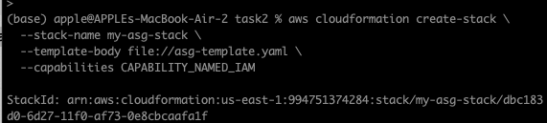

Step 4:

Monitor Stack Progress:

— aws cloudformation describe-stacks --stack-name my-asg-stack

Step 5:

Test Auto Scaling Group Behavior:

* Go to EC2 -> Instances

- Terminate the instance manually

- Auto Scaling Group will launch a new instance automatically

Output: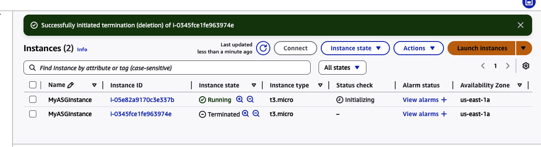

Step 6:

Clean Up Resources

Command: aws cloudformation delete-stack --stack-name my-asg-stack

Thanks and regards,  
Mahesh Gaddameeda |Trainee Software Engineer

**mahesh.gaddameeda@letitbexai.com** **/ LETITBE X AI TECH SOLUTIONS PVT LTD.**

